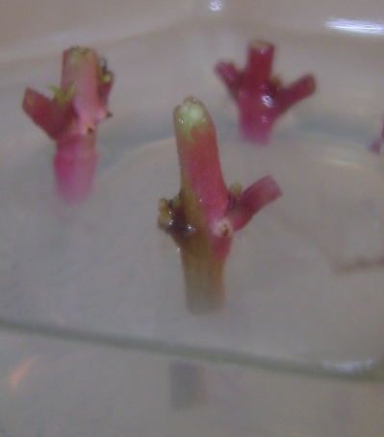 

Fig. 1 fig. 2

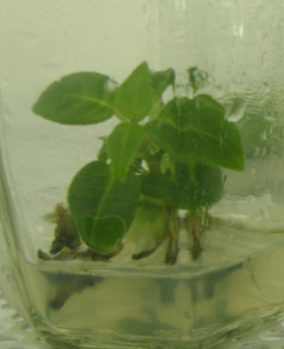

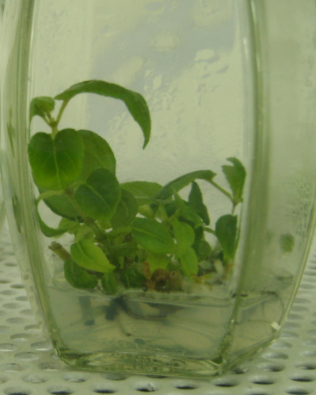

Fig. 3 Fig. 4

Fig 5a: 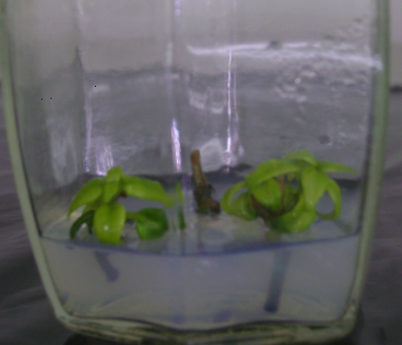 Fig 5b:

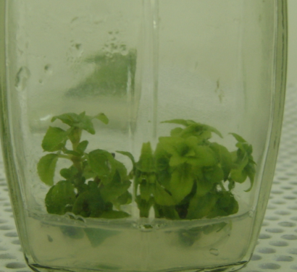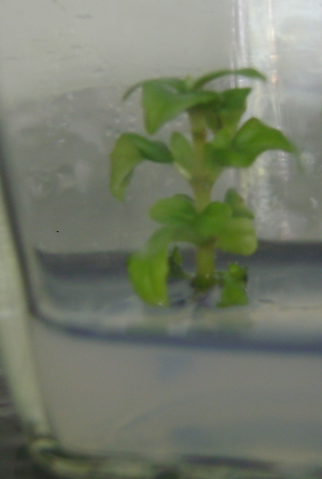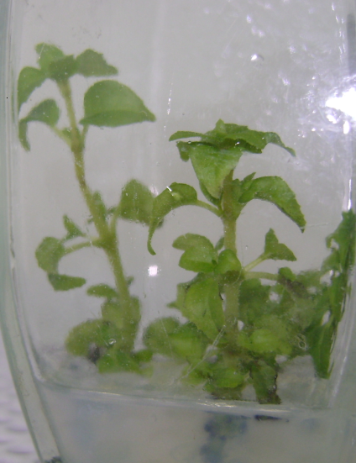

Fig6a: Fig6b:



Fig 7:

Fig 8a: 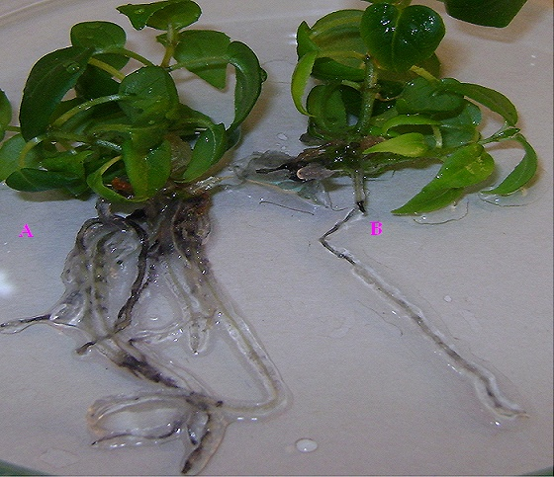

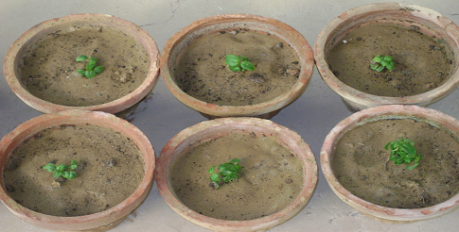 Fig 9:

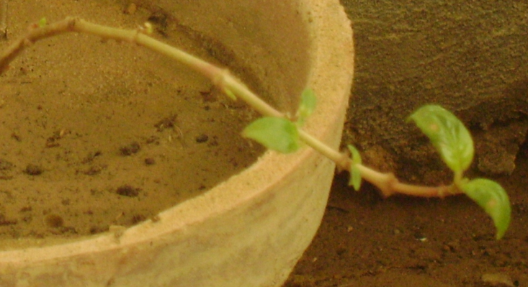 Fig 10:

**Figures Legends**

Figure 1: Axillary bud explant of *F. magellanica* cultured in initiation media.

Figure 2: In vitro initiation of shoots from Axillary bud explant of *Fuchsia magellanica* observed after 1 week of transfer to initiation media.

Figure 3: In vitro initiation of shoots from Axillary bud explant of *Fuchsia magellanica* observed after 2 weeks of transfer to initiation media.

Figure 4: In vitro initiation of shoots from Axillary bud explant of *F. magellanica* observed after 3 weeks of transfer to initiation media.

Figure 5a: control for multiplication.

Figure 5b: Multiplication of *F. magellanica* observed after 3 weeks of transfer to multiplication media.

Figure 6a: control for elongation

Figure 6b: Elongation of *Fuchsia magellanica* observed after 8 days of transfer to elongation media.

Fig 7: Graph showing the difference in shoot length of F. magellanica in control and test over a period of eight days.

Figure 8: Root development in *Fuchsia magellanica* observed after 1 month of transfer to rooting media (A) as compare to control (B).

Figure 9: Acclimatization of *Fuchsia magellanica*

Fig10: Control of Fuchsia magellanica showing initiation of leaf-formation after 25 days of transfer to soil.

Table legends:

Table 1: Effect of different concentrations of MS media on shoot induction from auxiliary buds

Table 2: Effect of hormones on different developmental stages of *Fuchsia magellanica*